Normalized Cloud Storage Entity for Public Cloud

OBJECTIVE
Our solution is based on a cryptographic usage of symmetric encryption used for enciphering the data file and asymmetric encryption for Meta data files, due to the highest sensibility of this information towards several intrusions. Besides, our solution is also shown to be resistant to unauthorized access to data and to any data disclosure during sharing process, providing two levels of access control verification.
INTRODUCTION:
Nowadays, the explosive growth of digital contents continues to rise the demand for new storage and network capacities, along with an increasing need for more cost effective use of storage and network bandwidth for data transfer. As such, the use of remote storage systems is gaining an expanding interest, namely the cloud storage based services, since it provides cost efficient architectures. These architectures support the transmission, storage in a multi-tenant environment, and intensive computation of outsourced data in a pay per use business model. This paper introduces a new cryptographic method for secure Proof of Ownership , based on the joint use of convergent encryption and the Merkle-based Tree, for improving data security in cloud storage systems, providing dynamic sharing between users and ensuring efficient data de-duplication. Our idea consists in using the Merkle-based Tree over encrypted data, in order to derive a unique identifier of outsourced data. On one hand, this identifier serves to check the availability of the same data in remote cloud servers. On the other hand, it is used to ensure efficient access control in dynamic sharing scenarios.

ABSTRACT
Recent years have witnessed the trend of leveraging cloud-based services for large scale content storage, processing, and distribution. Security and privacy are among top concerns for the public cloud environments. Towards these security challenges, we propose and implement, on Open Stack Swift, a new client-side de-duplication scheme for securely storing and sharing outsourced data via the public cloud. The originality of our proposal is twofold. First, it ensures better confidentiality towards unauthorized users. That is, every client computes per data key to encrypt the data that he intends to store in the cloud. As such, the data access is managed by the data owner. Second, by integrating access rights in metadata file, an authorized user can decipher an encrypted file only with his private key.

Existing System
Although the existing schemes aim at providing integrity verification for different data storage systems, data dynamics has not been fully addressed. How to achieve a secure and efficient design to seamlessly integrate these two important components for data storage service remains an open challenging task in Cloud storage.
DISADVANTAGES OF EXISTING SYSTEM:
- Although the infrastructures under the cloud are much more powerful and reliable than personal computing devices, they are still facing the broad range of both internal and external threats for data integrity.
- Second, there do exist various motivations for CSP to behave unfaithfully toward the cloud users regarding their outsourced data status.
- In particular, simply downloading all the data for its integrity verification is not a practical solution due to the expensiveness in I/O and transmission cost across the network. Besides, it is often insufficient to detect the data corruption only when accessing the data, as it does not give users correctness assurance for those un-accessed data and might be too late to recover the data loss or damage.
- Encryption does not completely solve the problem of protecting data privacy against cloud service provider but just reduces it to the complex key management domain. Unauthorized data leakage still remains possible due to the potential exposure of decryption keys.
Proposed System:
In Our Proposed Concept we analyse the use of the convergent encryption, i.e., deriving keys from the hash of plaintext. Then stored and pointed out some security problems, and presented a security model for secure data de-duplication. However, these two protocols focus on server-side de-duplication and do not consider data leakage settings, against malicious users.

Advantage:
- As a rising subject, cloud storage is playing an increasingly important role in the decision support activity of every walk of life.
- Get Efficient Item set result based on the de-duplication.

IMPLEMENTATION

The implementation stage involves careful planning, investigation of the existing system and it’s constraints on implementation, designing of methods to achieve changeover and evaluation of changeover methods.

- GENERAL ARCHITECTURE CLOUD STORAGE ENTITY
- GENERAL ARCHITECTURE FOR NORMALIZED CLOUD STORAGE ENTITY
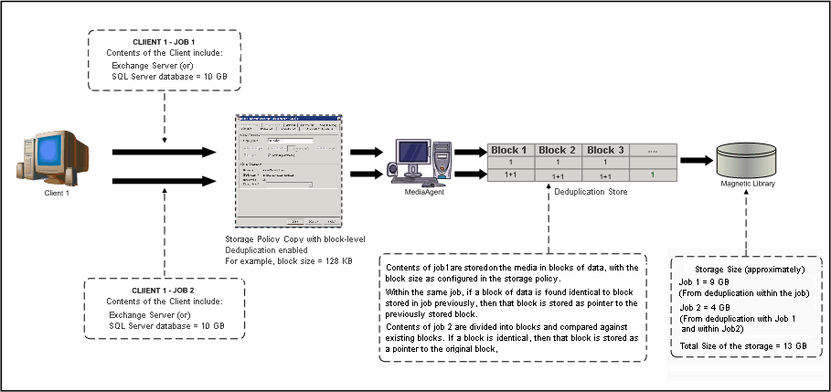

MODULES
- User Module.
- Client module.
- CSP Module.
- De-duplication module.

Modules Description
User Module
In this module, user should register their details and get the secret key for login and user can download the clients uploaded files the users are able to access the content stored in the cloud, depending on their access rights which are authorizations granted by the client, like the rights re-store the modified data in the cloud.

Client Module
In this module, a client makes use of provider’s resources to store, retrieve and share data with multiple users. A client can be either an individual or an enterprise that can able to check the uploaded file he can avoid or upload the files. Client can view the de-duplicate file based on this client can delete the unwanted Files.
CSP Module:
In this module CSP can view all the user details, client uploads details, clients detail and clients activities regarding the a Secure Client Side De-duplication Scheme in Cloud Storage Environments
De-duplication module:
In this module the clients will upload files that can be stored in cloud database and will built secure clients who can view the file from the database based on the de-duplicate Scheme Hence we Provide a highest Performing Secure Client With Normalized Cloud.
System Configuration:-

H/W System Configuration:-

Processor - Pentium –III

Speed - 1.1 GHz

RAM - 256 MB

Hard Disk - 20 GB

Floppy Drive - 1.44 MB

Key Board - Standard Windows Keyboard

Mouse - Two or Three Button Mouse

Monitor - SVGA

S/W System Configuration:-

Operating System : Windows 7
Front End : Asp.Net
Language : C#
IDE : Visual Studio 2010
Database : Sql server 2008

CONCLUSION
The growing need for secure cloud storage services and the attractive properties of the convergent cryptography lead us to combine them, thus, defining an innovative solution to the data outsourcing security and efficiency issues. Our solution is based on a cryptographic usage of symmetric encryption used for enciphering the data file and asymmetric encryption for Meta data files, due to the highest sensibility of this information towards several intrusions. In addition, thanks to the Merkle tree properties, this proposal is shown to support data de-duplication, as it employs anpre-verfication of data existence, in cloud servers, which is useful for saving bandwidth. Besides, our solution is also shown to be resistant to unauthorized access to data and to any data disclosure during sharing process, providing two levels of access control verification. Finally, we believe that cloud data storage security is still full of challenges and of paramount importance, and many research problems remain to be identified.

